**PART A:**First of all, here you can see the client and server files, and the output:  
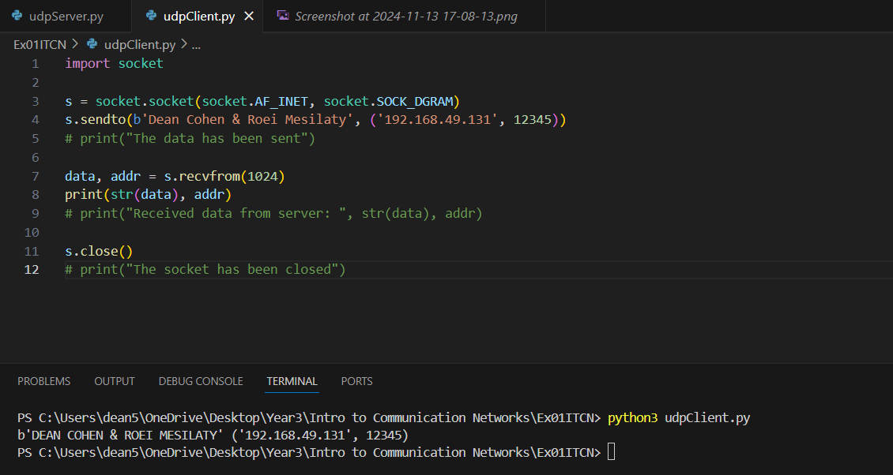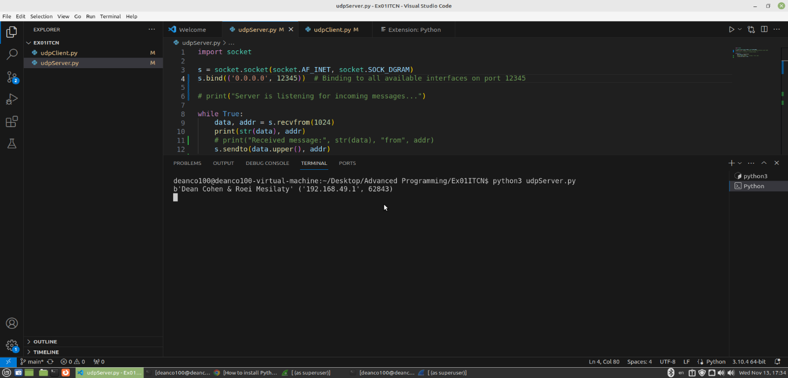



**Code explanation:**The code has client and server files.  
The client file uses a socket to send a message to the IP address of the VM (which runs the server). Then, the server file uses the socket to receive and print (one or more) message(s) from the client. After that, the server sends a message (in upper case) back to the client address (which he knows from the client’s first message) and the client receives the message and print it.  
The client and the server are bound to port 12345.

**Relationship between Code and Traffic:**

The client code sends a message to the server, and this message is captured in the first Wireshark packet (Image 1). The server receives this message, processes it, and sends the response back to the client. This response is captured in the second Wireshark packet (Image 2).

The code directly affected the network traffic by defining the contents of the UDP payload, the source and destination ports, and the overall flow of the communication between the client and server.

Image1 **(NOTE: len(“Dean Cohen & Roei Mesilaty) = 26):**

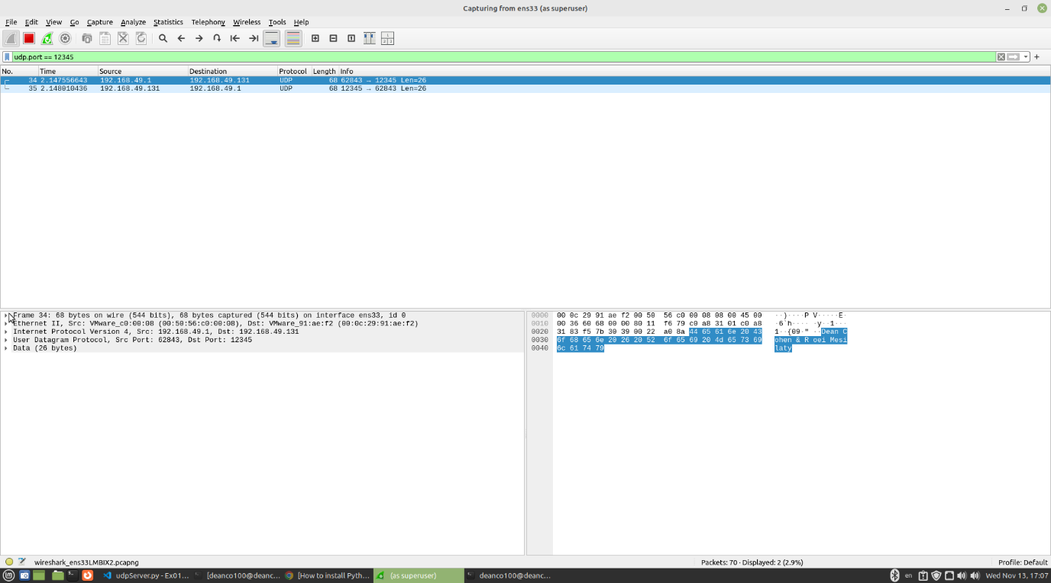

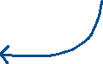

Image2:  
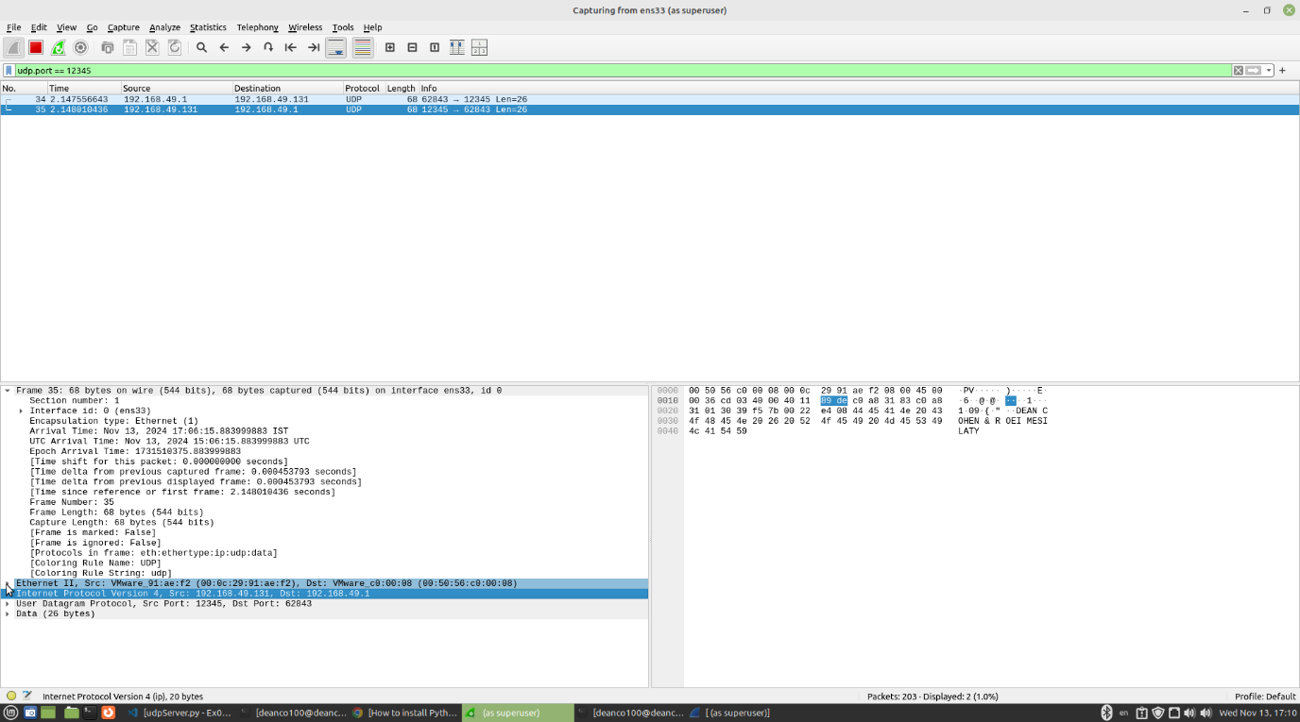



######## **NEED TO ADD THE LAYERS EXPLANATION AND THE SCREENSHOTS ########**